Backpropagation Step by Step
15 FEB 2018
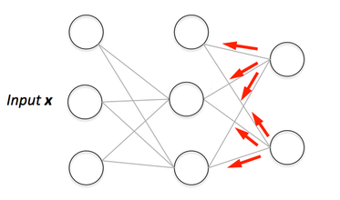If you are building your own neural network, you will definitely need to understand how to train it. Backpropagation is a commonly used technique for training neural network. There are many resources explaining the technique, but this post will explain backpropagation with concrete example in a very detailed colorful steps.

Overview
In this post, we will build a neural network with three layers:
- Input layer with two inputs neurons
- One hidden layer with two neurons
- Output layer with a single neuron
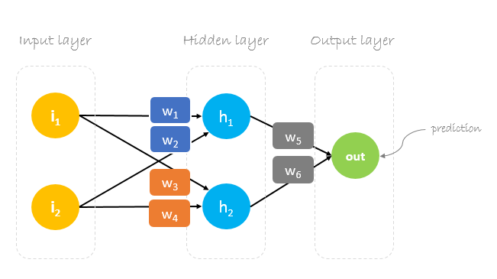

Weights, weights, weights
Neural network training is about finding weights that minimize prediction error. We usually start our training with a set of randomly generated weights.Then, backpropagation is used to update the weights in an attempt to correctly map arbitrary inputs to outputs.
Our initial weights will be as following: w1 = 0.11, w2 = 0.21, w3 = 0.12, w4 = 0.08, w5 = 0.14 and w6 = 0.15
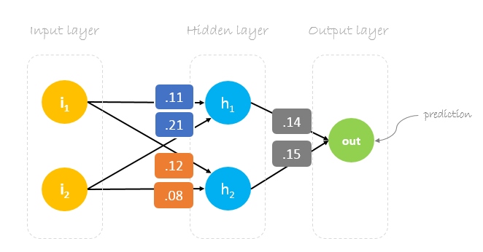

Dataset
Our dataset has one sample with two inputs and one output.
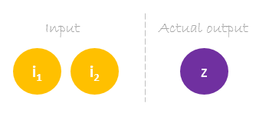
Our single sample is as following inputs=[2, 3] and output=[1].
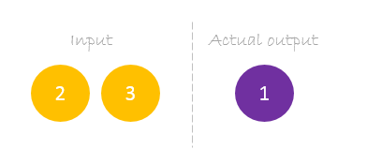

Forward Pass
We will use given weights and inputs to predict the output. Inputs are multiplied by weights; the results are then passed forward to next layer.
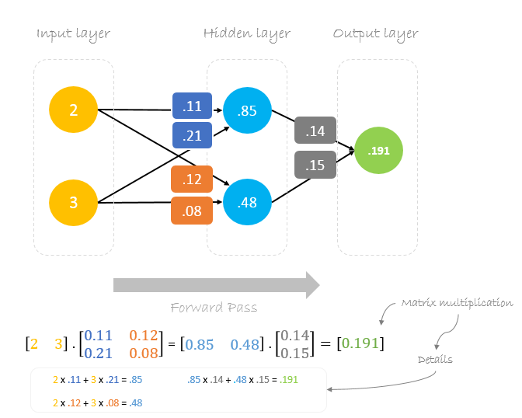

Calculating Error
Now, it’s time to find out how our network performed by calculating the difference between the actual output and predicted one. It’s clear that our network output, or prediction, is not even close to actual output. We can calculate the difference or the error as following.
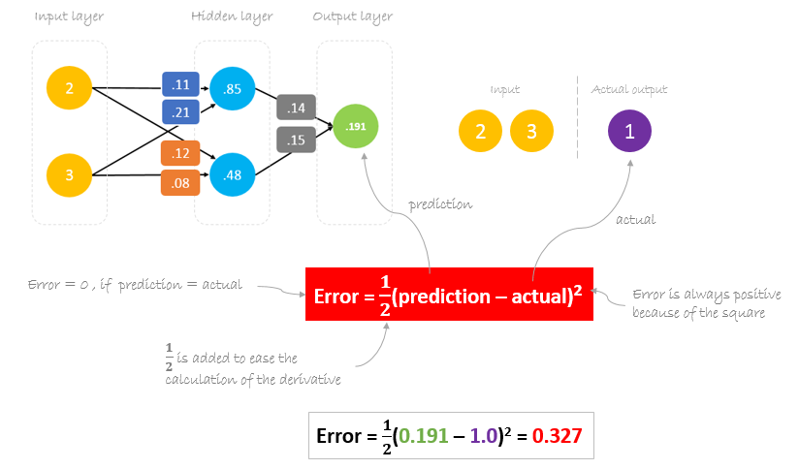

Reducing Error
Our main goal of the training is to reduce the error or the difference between prediction and actual output. Since actual output is constant, “not changing”, the only way to reduce the error is to change prediction value. The question now is, how to change prediction value?
By decomposing prediction into its basic elements we can find that weights are the variable elements affecting prediction value. In other words, in order to change prediction value, we need to change weights values.
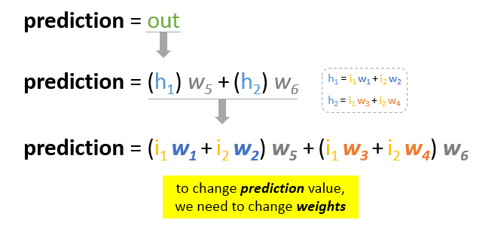
The question now is how to change\update the weights value so that the error is reduced?
The answer is Backpropagation!

Backpropagation
Backpropagation, short for “backward propagation of errors”, is a mechanism used to update the weights using gradient descent. It calculates the gradient of the error function with respect to the neural network’s weights. The calculation proceeds backwards through the network.
Gradient descent is an iterative optimization algorithm for finding the minimum of a function; in our case we want to minimize th error function. To find a local minimum of a function using gradient descent, one takes steps proportional to the negative of the gradient of the function at the current point.
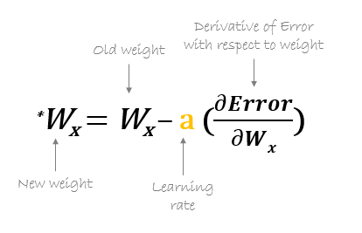
For example, to update w6, we take the current w6 and subtract the partial derivative of error function with respect to w6. Optionally, we multiply the derivative of the error function by a selected number to make sure that the new updated weight is minimizing the error function; this number is called learning rate.
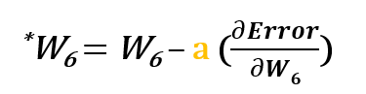
The derivation of the error function is evaluated by applying the chain rule as following
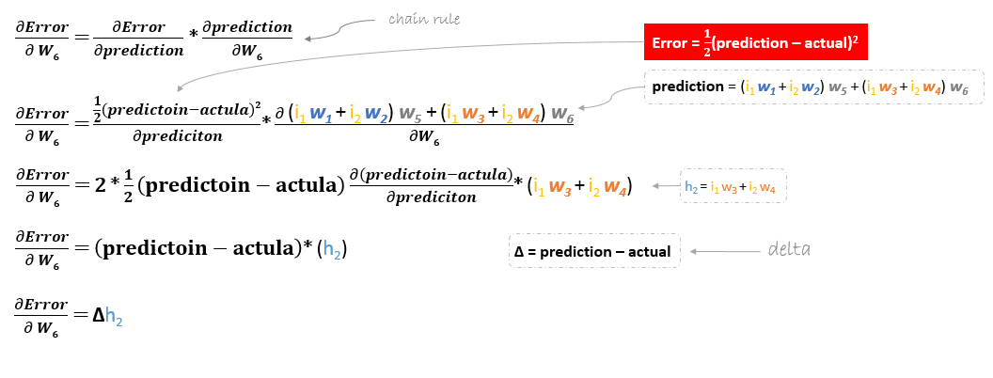
So to update w6 we can apply the following formula
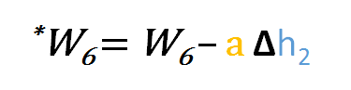
Similarly, we can derive the update formula for w5 and any other weights existing between the output and the hidden layer.
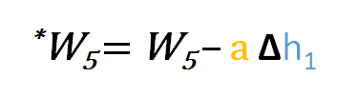
However, when moving backward to update w1, w2, w3 and w4 existing between input and hidden layer, the partial derivative for the error function with respect to w1, for example, will be as following.
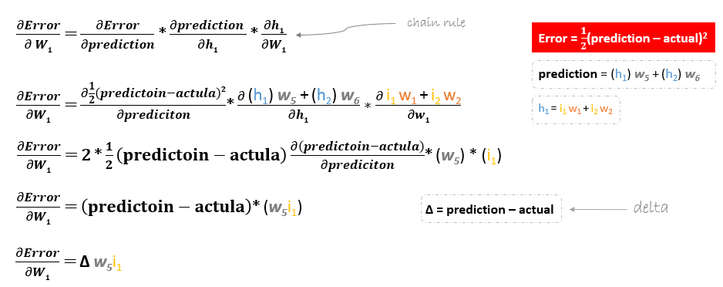
We can find the update formula for the remaining weights w2, w3 and w4 in the same way.
In summary, the update formulas for all weights will be as following:
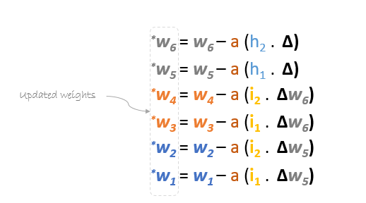
We can rewrite the update formulas in matrices as following
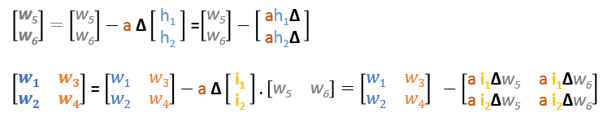

Backward Pass
Using derived formulas we can find the new weights.
Learning rate: is a hyperparameter which means that we need to manually guess its value.
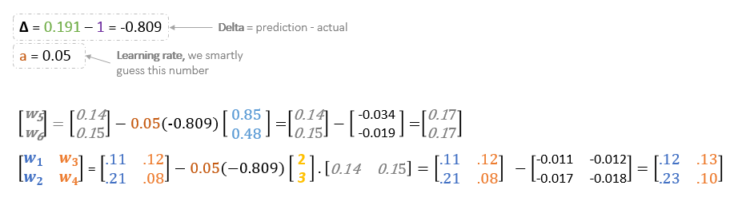
Now, using the new weights we will repeat the forward passed
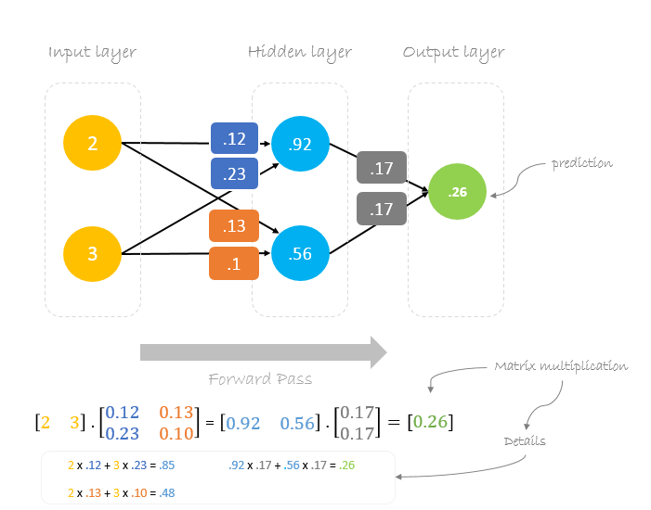
We can notice that the prediction 0.26 is a little bit closer to actual output than the previously predicted one 0.191. We can repeat the same process of backward and forward pass until error is close or equal to zero.

Overview
For this tutorial, we’re going to use a neural network with two inputs, two hidden neurons, two output neurons. Additionally, the hidden and output neurons will include a bias.
Here’s the basic structure:
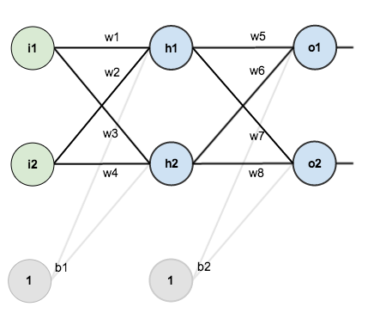
In order to have some numbers to work with, here are the initial weights, the biases, and training inputs/outputs:
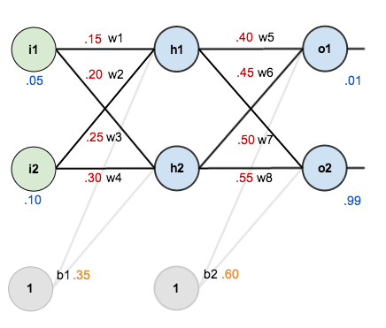
The goal of backpropagation is to optimize the weights so that the neural network can learn how to correctly map arbitrary inputs to outputs.
For the rest of this tutorial we’re going to work with a single training set: given inputs 0.05 and 0.10, we want the neural network to output 0.01 and 0.99.

The Forward Pass
To begin, lets see what the neural network currently predicts given the weights and biases above and inputs of 0.05 and 0.10. To do this we’ll feed those inputs forward though the network.
We figure out the total net input to each hidden layer neuron, squash the total net input using an activation function (here we use the logistic function), then repeat the process with the output layer neurons.
Total net input is also referred to as just net input by some sources.
Here’s how we calculate the total net input for :
We then squash it using the logistic function to get the output of :
Carrying out the same process for we get:
We repeat this process for the output layer neurons, using the output from the hidden layer neurons as inputs.
Here’s the output for :
And carrying out the same process for we get:

Calculating the Total Error
We can now calculate the error for each output neuron using the squared error function and sum them to get the total error:
Some sources refer to the target as the ideal and the output as the actual.
The is included so that exponent is cancelled when we differentiate later on. The result is eventually multiplied by a learning rate anyway so it doesn’t matter that we introduce a constant here [1].
For example, the target output for is 0.01 but the neural network output 0.75136507, therefore its error is:
Repeating this process for (remembering that the target is 0.99) we get:
The total error for the neural network is the sum of these errors:

The Backwards Pass
Our goal with backpropagation is to update each of the weights in the network so that they cause the actual output to be closer the target output, thereby minimizing the error for each output neuron and the network as a whole.

Output Layer
Consider . We want to know how much a change in affects the total error, aka .
is read as “the partial derivative of with respect to “. You can also say “the gradient with respect to “.
By applying the chain rule we know that:

Visually, here’s what we’re doing:
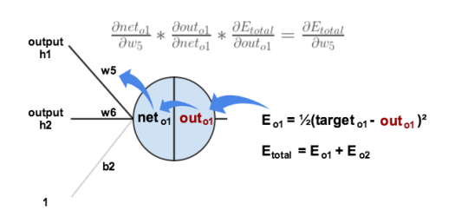
We need to figure out each piece in this equation.
First, how much does the total error change with respect to the output?
is sometimes expressed as
When we take the partial derivative of the total error with respect to , the quantity becomes zero because does not affect it which means we’re taking the derivative of a constant which is zero.
Next, how much does the output of change with respect to its total net input?
The partial derivative of the logistic function is the output multiplied by 1 minus the output:
Finally, how much does the total net input of change with respect to ?
Putting it all together:

You’ll often see this calculation combined in the form of the delta rule:
Alternatively, we have and which can be written as , aka (the Greek letter delta) aka the node delta. We can use this to rewrite the calculation above:

Therefore:
Some sources extract the negative sign from so it would be written as:
To decrease the error, we then subtract this value from the current weight (optionally multiplied by some learning rate, eta, which we’ll set to 0.5):
Some sources use (alpha) to represent the learning rate, others use (eta), and others even use (epsilon).
We can repeat this process to get the new weights , , and :
We perform the actual updates in the neural network after we have the new weights leading into the hidden layer neurons (ie, we use the original weights, not the updated weights, when we continue the backpropagation algorithm below).

Hidden Layer
Next, we’ll continue the backwards pass by calculating new values for , , , and .
Big picture, here’s what we need to figure out:

Visually:
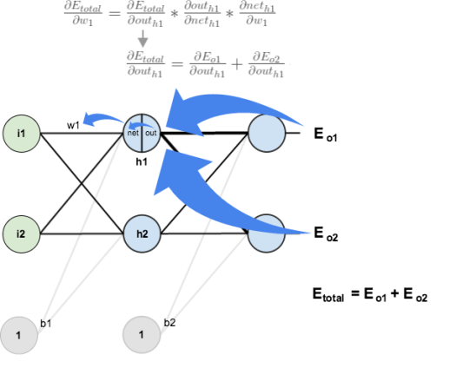
We’re going to use a similar process as we did for the output layer, but slightly different to account for the fact that the output of each hidden layer neuron contributes to the output (and therefore error) of multiple output neurons. We know that affects both and therefore the needs to take into consideration its effect on the both output neurons:

Starting with :

We can calculate using values we calculated earlier:

And is equal to :
Plugging them in:

Following the same process for , we get:
Therefore:

Now that we have , we need to figure out and then for each weight:
We calculate the partial derivative of the total net input to with respect to the same as we did for the output neuron:
Putting it all together:

You might also see this written as:

We can now update :
Repeating this for , , and
Finally, we’ve updated all of our weights! When we fed forward the 0.05 and 0.1 inputs originally, the error on the network was 0.298371109. After this first round of backpropagation, the total error is now down to 0.291027924. It might not seem like much, but after repeating this process 10,000 times, for example, the error plummets to 0.0000351085. At this point, when we feed forward 0.05 and 0.1, the two outputs neurons generate 0.015912196 (vs 0.01 target) and 0.984065734 (vs 0.99 target).

